

Open Call for regional test-beds

**Application Form**

The Invest4Health project has received funding from the European Union's Horizon Europe Research and Innovation Programme under Grant Agreement 101095522

The participation of UK partner Bangor University in this project is supported by UKRI grant number 10065737

The participation of UK partner University of Oxford in this project is supported by UKRI grant number 10061251

The participation of UK partner Hywel Dda University Health Board is supported by UKRI grant number 10063637

DISCLAIMER

|  |
| --- |
| Funded by the European Union and UKRI. Views and opinions expressed are, however, those of the author(s) only and do not necessarily reflect those of the European Union or HADEA or UKRI. Neither the European Union nor the granting authorities can be held responsible for them.  The work associated with this document has been carried out in accordance with the highest technical standards, and Invest4Health partners have endeavoured to achieve the degree of accuracy and reliability appropriate to the work in question. However, since the partners have no control over the use to which the information contained within the document is put by any other party, any other such party shall be deemed to have satisfied itself as to the suitability and reliability of the information in relation to any particular use, purpose, or application.  Under no circumstances will any of the partners, their employees, or agents accept any liability whatsoever arising out of any error or inaccuracy contained in this document (or any further consolidation, summary, publication, or dissemination of the information contained within this document) and/or the connected work and disclaim all liability for any loss, damage, expenses, claims, or infringement of third-party rights. |

Table of Contents

DISCLAIMER 2

Table of Contents 3

1 Legal Information 4

1.1 Applicant information 4

1.2 Organization information 5

2 Eligibility self-declaration 6

3 Application 7

IMPORTANT NOTICE: THIS DOCUMENT CANNOT BE MODIFIED. PLEASE ONLY ENTER YOUR INFORMATION IN THE INDICATED FIELDS. IN ADDITION TO THIS APPLICATION FORM, YOU ALSO NEED TO FILL OUT AND SUBMIT THE DECLARATION OF HONOUR AND SUBMIT A PROOF OF EXISTENCE OF LEGAL ENTITY, TO COMPLETE YOUR APPLICATION.

Please send your completed application documents **in PDF format** to the following email address: [invest4health.opencall@norwayhealthtech.com](mailto:invest4health.opencall@norwayhealthtech.com)

1. Legal Information
   1. Applicant information

Please enter your personal details, using the fields below. **All fields marked with * are mandatory.**

|  |
| --- |
| **\*First name:** |
| *Enter your first name here* |

|  |
| --- |
| **\*Last name:** |
| *Enter your last name here* |

|  |
| --- |
| **\*Email:** |
| *Enter your email address here* |

|  |
| --- |
| **\*Phone number:** |
| *Enter your phone number here, including country code (e.g. +47 123456789)* |

|  |
| --- |
| **Gender:** |
| *Enter your gender here (optional)* |

|  |
| --- |
| **\*Position within organization:** |
| *Enter your position/ role/ job title in your organization here* |

* 1. Organization information

Please enter the details of the organization you are representing in this application, using the fields below. **All fields marked with * are mandatory.**

|  |
| --- |
| **\*Organization legal name:** |
| *Enter information here* |

|  |
| --- |
| **\*Registration number/ VAT number/ Tax identification number:** |
| *Enter information here* |

|  |
| --- |
| **\*Organization short name:** |
| *Enter information here* |

|  |
| --- |
| **\*Organization type:** |
| *Enter information here (e.g. public sector, private company, non-profit organization, etc.)* |

|  |
| --- |
| **\*Organization size:** |
| *Enter the number of employees of your organization here* |

|  |
| --- |
| **\*Legal address:** |
| *Enter information here* |

|  |
| --- |
| **\*City/Town:** |
| *Enter information here* |

|  |
| --- |
| **\*Province/Region/County:** |
| *Enter information here* |

|  |
| --- |
| **\*Country:** |
| *Enter information here* |

|  |
| --- |
| **\*Organization phone number (Country code + number):** |
| *Enter your organization’s phone number here, including country code (e.g. +47 123456789)* |

|  |
| --- |
| **\*Organization website:** |
| *Enter information here* |

1. Eligibility self-declaration

**Table 1: Eligibility criteria**

|  |  |
| --- | --- |
| **Eligibility criteria** | *All the following criteria must be fulfilled for an application to be considered eligible for evaluation.* |
| Legal entity: | All applicant organizations must be established legal entities in one of the EU Member States (MS), or third countries associated to the Horizon Europe programme**[1]**. |
| Health promotion and disease prevention relevance | All applications must focus on and cover at least one health promotion area and/ or disease prevention category**[2]** |
| Application completion | All requested application documents must be submitted within the deadline. Incomplete applications will be rejected. All applications must be submitted in English, as the working language of the Invest4Health consortium. The legal entity proof may be submitted in local/original languages. |
| Number of applications submitted: | Applicant organizations can only submit one (1) application as leaders. If there are multiple applications submitted from the same lead organization/entity, only the most recently submitted will be considered. |

Please provide your eligibility information, using the fields below. **All fields are mandatory**.

|  |
| --- |
| **Is your organization currently a legally registered entity in one of the EU Member States, or third countries associated with the Horizon Europe programme? (Yes/No):** |
| *Enter information here* |

|  |
| --- |
| **Does your proposed initiative in this application cover at least one health promotion area and/or disease prevention category? (Yes/No):** |
| *Enter information here* |

|  |
| --- |
| **Have you or your organization submitted another application for the Invest4Health Open Call as leader? (Yes/No):** |
| *Enter information here* |

1. Application

Please use the fields below to provide information on your application. **All fields are mandatory**. Important: Please **make sure to not exceed the word limit** indicated in each of the fields. Any words exceeding the limit will not be considered during the application evaluation.

|  |
| --- |
| **Motivation for Invest4Health collaboration/ strategic fit (word limit: 300 words)** |
| *Describe why you wish to collaborate with the Invest4Health project and how it could benefit your proposed initiative. An interest in working with and testing alternative financing/ investment models should be clearly stated and explained (e.g. what is the need for investment/ investment gap). (max. 300 words)* |

|  |
| --- |
| **Description of your initiative (word limit: 800 words)** |
| *Provide a clear description of your proposed initiative, including the problem statement, its objectives/ outcomes/ results, and milestones to achieve its expected results.   The health promotion area and/or disease prevention category your proposed initiative covers should also be mentioned, and social determinants of health should be considered.*  *Relevance to regional and/or European health promotion and disease prevention objectives will be positively evaluated. (max. 800 words)* |

|  |
| --- |
| **Readiness to test (word limit: 500 words)** |
| *Provide a clear description of the soft-infrastructure and the facilities where your test-bed team can simulate, experiment, and test. Please also provide information on the staff/ team members who will participate in the Invest4Health activities, the size of the team involved, and the resources that your proposed initiative/ test-bed will provide to support your participation in the Invest4Health activities. (max. 500 words)* |

|  |
| --- |
| **Team composition (word limit: 500 words)** |
| *Provide information on your test-bed team, including expertise. Multidisciplinary and multistakeholder teams will be positively evaluated with extra points. Involving multiple organizations in the application/ team is not required but will be positively evaluated when bringing added value. (max. 500 words)   N.B.: Extra points will be awarded for active involvement of policy and/or decision makers (particularly in charge of financing)* |

|  |
| --- |
| **Stakeholder engagement (word limit: 500 words)** |
| *Describe which stakeholders you will target in order to understand their needs and generate momentum for your initiative (e.g., regional and health authorities, investors, charities, social enterprises, solution providers, community/ citizen driven initiatives, end users, etc.), as well as provide with a plan on how to engage with them in the mid/long-term. (max. 500 words)* |

|  |
| --- |
| **Societal impact (word limit: 500 words)** |
| *Describe the societal, health, economic, and environmental impact of your initiative/ intervention, as well as ethical, gender, and diversity considerations. The inclusion of specific metrics and performance indicators (KPIs) will be positively evaluated. (max 500 words)* |

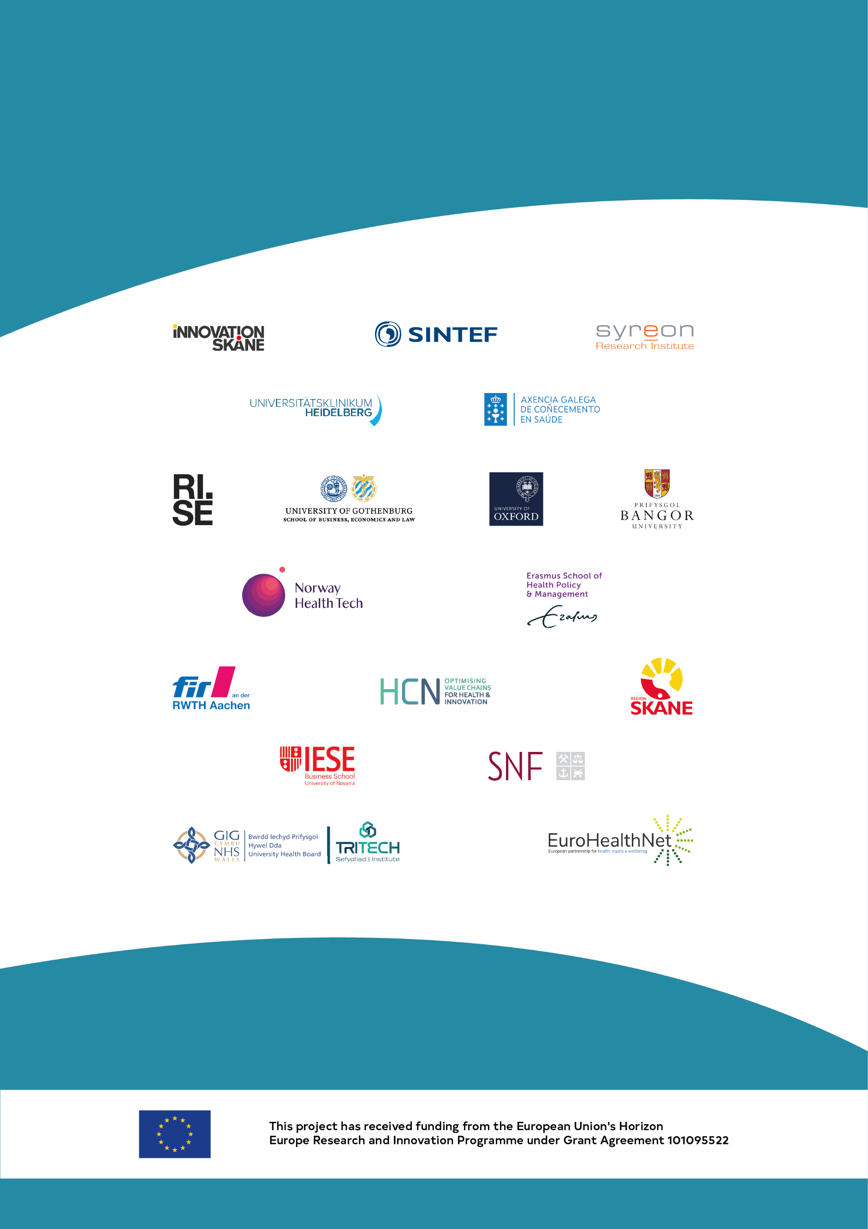

1. [Updates on the association of third countries to Horizon Europe - European Commission](https://research-and-innovation.ec.europa.eu/news/all-research-and-innovation-news/updates-association-third-countries-horizon-europe-2021-12-21_en)
2. [Health Promotion and Disease Prevention | Knowledge for policy - European Commission](https://knowledge4policy.ec.europa.eu/health-promotion-knowledge-gateway/promotion-prevention_en#diseaseprevention)